## 

## 

**AIxplorer**

**50.045 Information Retrieval**

**Project Report**

Yu Qin (1005327), Ge Ziyu (1004880),

Koh Aik Hong (1005139), Wang Zhuoran (1004867)

**Table of Contents**

**1. Problem Statement 1**

**2. Dataset 2**

Overview 2

Procedures 3

**3. Retrieval Technique 5**

Text Splitter 5

Vector Store 5

Embedding Choice 6

Retriever 7

BM25 7

Maximum Marginal Relevance Retrieval (MMR) 7

Similarity Search 7

MultiQuery Retriever (Query Expansion) 7

Evaluation 8

Methodology used to label the retrieved documents 8

LLM Labeling 8

Manual Labeling 9

Evaluation Metrics 9

Results 10

Analysis of Evaluation Result 11

**4. Generation Using LLM 12**

LLM Selection Rationale 12

Selected LLMs 12

Generation Methodology 14

LLM Output Analysis 15

**5. Verification of LLM Output Using Retrieved Documents 17**

Using an LLM to Verify if the Output Matches the Content of the Documents 17

Using Various Score Metrics to Verify if the LLM Generated Output Matches the Content of the Documents 19

**6. Generation of Citations for Verified LLM Output. 21**

**7. LLM Generation using RAG 23**

**8. LLM Performance Evaluation without RAG 24**

Results 24

LLM Evaluation 24

Results 25

Analysis of Evaluation Results 26

**9. LLM Performance Evaluation with RAG 27**

Results for Score Metrics 27

Results for LLM Self-Evaluation 27

Analysis of Evaluation Results 29

**10. Conclusion 30**

**11. References 32**

**12. Appendix 34**

Appendix A 34

Appendix B 35

Appendix C 36

Appendix D 42

Appendix E 53

Appendix E 55

## 

## 1. Problem Statement

In the realm of academic research, particularly within computer science, traditional conference paper search engines often inundate researchers with excessive information. This abundance of data poses a significant challenge for researchers seeking to locate papers pertinent to their specific queries or problems. While Large Language Models (LLMs) have shown promise as effective research assistants, they are hampered by a critical limitation: the lack of access to the most recent knowledge and publications.

To address these challenges, we propose a novel solution: a Retrieval Augmented Generation (RAG) system tailored for computer science research. This system is designed to synergize the strengths of Information Retrieval techniques and the advanced capabilities of Large Language Models. It establishes a question-answering framework that operates by:

1. Utilizing a specialized paper retrieval component to connect with an external database. This component is responsible for sourcing relevant papers and information pertinent to the user's query.
2. Integrating these findings with the analytical prowess of a Large Language Model, which then processes the retrieved documents to generate concise, informative answers.

By combining these two approaches, our RAG system aims to empower users with the ability to quickly and efficiently access precise answers within the field of computer science. This fusion of up-to-date information retrieval with the contextual understanding of LLMs presents a significant advancement in academic research methodologies, offering a streamlined and effective tool for scholars navigating the vast landscape of conference papers and publications.

## 

## 

## 2. Dataset

### Overview

The complete dataset construction process is as indicated in Figure 1 below.

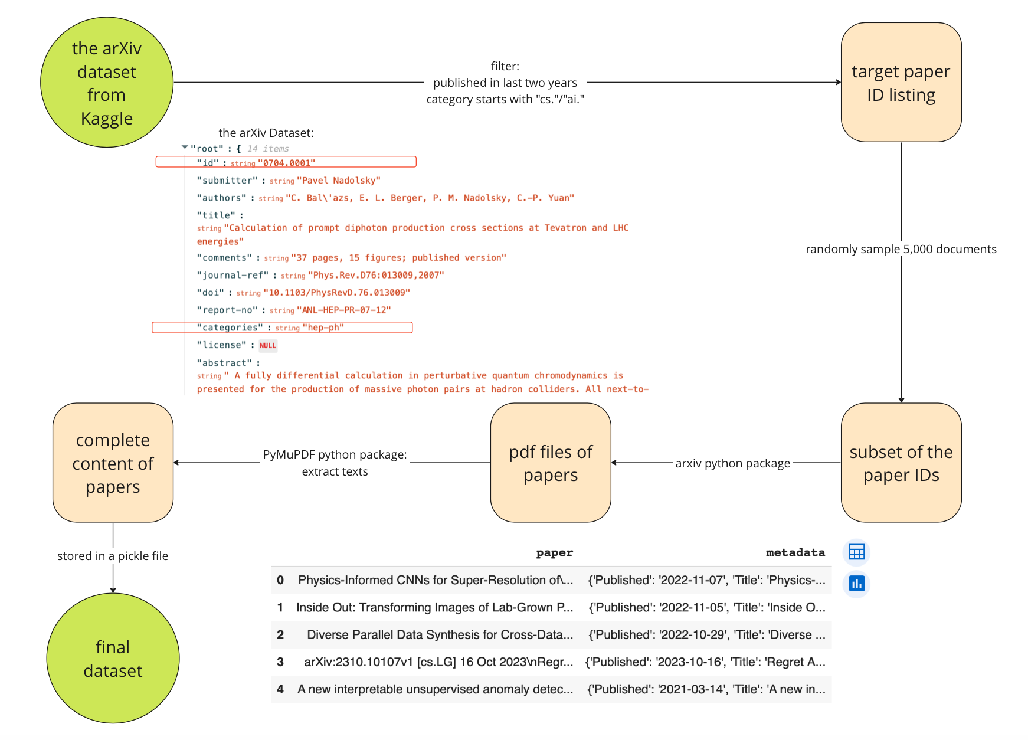  
Figure 1: An Overview of Dataset Construction Procedures

### 

### Procedures

Our dataset is derived from the arXiv Dataset, hosted by Cornell University on Kaggle. The arXiv Dataset provides only a metadata file in the json format. This file contains an entry for each paper. Each entry consists of the following elements illustrated in Table 1.

| Name | Content |
| --- | --- |
| id | ArXiv ID |
| submitter | Who submitted the paper |
| authors | Authors of the paper |
| title | Title of the paper |
| comments | Additional info, such as number of pages and figures |
| journal-ref | Information about the journal the paper was published in |
| doi | [https://www.doi.org](Digital Object Identifier) |
| abstract | The abstract of the paper |
| categories | Categories / tags in the ArXiv system |
| versions | A version history |

Table 1: Data Fields contained in the arXiv Dataset

As paper content is absent, we only utilize the dataset to generate the targeted paper ID listing. To align the dataset with our research focus on Computer Science, we filtered for papers published in the last two years and used regular expressions to identify those categorized as 'cs' or 'ai'. This process yielded a curated dataset containing 170,275 paper IDs.

Given the constraints of computing resources, we streamlined our approach by creating a smaller subset of the dataset, randomly sampling 5,000 IDs from the original collection of 170,275 paper IDs. To access the complete content of these papers, we utilized the arXiv library to get PDF files and the PyMuPDF library to extract the complete text content of each paper. This tool is specifically designed to fetch papers using their ArXiv IDs and efficiently convert them from their native PDF format into text. The conversion process resulted in Langchain document objects, each containing 2 attributes: both the metadata and the textual content of the paper. This amalgamated data was then serialized and stored in pickle files. Pickle files offer a compact, binary format for Python objects, making them a practical choice for storing and retrieving large datasets like ours. The file can be read by Pandas as shown below.

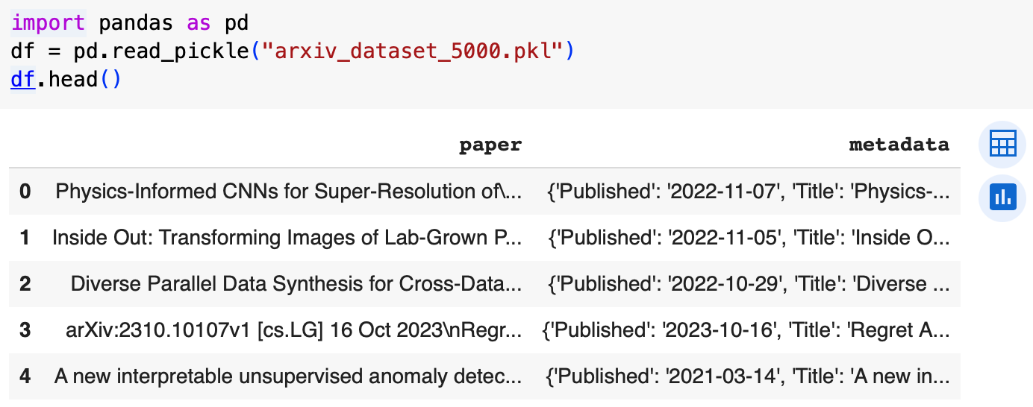

Figure 2: Curated Dataset Read Using Pandas

## 

## 3. Retrieval Technique

### Text Splitter

Language models are limited by a maximum token count, requiring the division of long texts into smaller segments. Accurate token counting is essential when segmenting texts. For this purpose, we utilized RecursiveCharacterTextSplitter.from_tiktoken_encoder, configuring it with a chunk size of 400, to break down entire papers into chunks of manageable sizes. This method splits the text based on specific characters and measures the chunk size using the tiktoken tokenizer.

RecursiveCharacterTextSplitter is recommended for general text segmentation. It uses a character list to sequentially divide the text into appropriately sized chunks. The default character list [“\n\n”, "\n", " ", “”] aims to maintain the integrity of paragraphs, sentences, and words for as long as possible due to their semantic coherence.

The tiktoken tokenizer is an efficient Byte-Pair Encoding (BPE) tokenizer developed by OpenAI. BPE progressively merges frequent byte or character pairs in a text dataset until reaching a target vocabulary size.

Using RecursiveCharacterTextSplitter.from_tiktoken_encoder ensures that each text segment adheres to the token limits of the language model. This method differs from CharacterTextSplitter.from_tiktoken_encoder, which solely relies on CharacterTextSplitter for segmentation and may result in splits exceeding the tiktoken tokenizer's chunk size. The recursive approach guarantees that if a split exceeds the permissible size, it will be further divided.

### Vector Store

In exploring vector storage solutions, we tested both FAISS and Chroma. FAISS, developed by Facebook AI Research, is efficient in high-dimensional vector searches. In our experiment, it quickly processes 7,000 documents in 40 minutes. However, integrating FAISS with the langchain library presented challenges due to compatibility issues with its GPU package, complicating script adjustments on Google Colab. Thus, we switched to Chroma DB, another open-source embedding database conducive to building Large Language Model (LLM) applications. Chroma stands out for its user-friendliness, allowing for the integration of custom embedding models, user-generated queries, and metadata-based filtering. This made Chroma a more practical choice for our project, balancing ease of use with versatility.

### Embedding Choice

We investigated several top-rated models from the Massive Text Embedding Benchmark (MTEB) Leaderboard on HuggingFace, focusing on embedding dimensions between 384 and 1024. Additionally, we explored the impact of newline characters ('/n') by embedding datasets both with and without them. The models we experimented with, their sizes, embedding dimensions, and the corresponding vector stores created are as follows:

| Model | Model Size (GB) | Embedding Dimensions | Vector Stores Created |
| --- | --- | --- | --- |
| all-MiniLM-L6-v2 | 0.13 | 384 | all-MiniLM-L6-v2_with_newline, all-MiniLM-L6-v2_without_newline, |
| all-mpnet-base-v2 | 0.44 | 768 | all-mpnet-base-v2_with_newline, all-mpnet-base-v2_without_newline |
| bge-base-en-v1.5 | 0.44 | 768 | bge-base-en-v1.5_with_newline, bge-base-en-v1.5_without_newline |
| bge-small-en-v1.5 | 0.13 | 384 | bge-small-en-v1.5_with_newline, bge-small-en-v1.5_without_newline |
| bge-large-en-v1.5 | 1.34 | 1024 | Failed to create vector stores due to limited computing resources. |
| ember-v1 | 1.34 | 1024 | Failed to create vector stores due to limited computing resources. |
| Cohere-embed-english-light-v3.0 | NA | 1024 | Failed to create vector stores due to limited computing resources. |

Table 2: Vector Database Embedded by Different Models

We found that models with embedding dimensions of 1024 were not manageable with the T4 GPU resources provided by Google Colab. Consequently, we created 8 vector stores with the smaller models.

### Retriever

In our research, we explored various retrievers, mainly focusing on BM25, Maximum Marginal Relevance Retrieval, Similarity Search and MultiQuery Retriever.

#### BM25

This is a widely recognized retrieval function rooted in the probabilistic information retrieval model. It ranks documents by considering the frequency of query terms in each document, without factoring in the interrelation of these terms. BM25's efficacy in a range of text retrieval scenarios makes it a go-to baseline in many information retrieval tasks.

#### Maximum Marginal Relevance Retrieval (MMR)

This method selects examples by balancing similarity to the input with the need for diversity in the results. It first identifies examples with the highest cosine similarity to the input embeddings. Then, in an iterative process, it adds these examples to the result set, applying penalties for similarity to examples already chosen. This approach ensures that the retrieved examples are not only relevant but also varied, providing a more rounded perspective on the query subject.

#### Similarity Search

As the name suggests, this technique selects documents based on similarity to the input query. It does this by finding the examples with the embeddings that have the greatest cosine similarity with the inputs.

#### MultiQuery Retriever (Query Expansion)

This retriever enhances the traditional query process by employing a Large Language Model (In the research, we utilized mistral-7b-openorca.) to generate multiple queries from varying perspectives based on a single user input. Below is an example, the original query "What is the state of the art object detection model used in computer vision?" has been expanded to 3 similar queries.

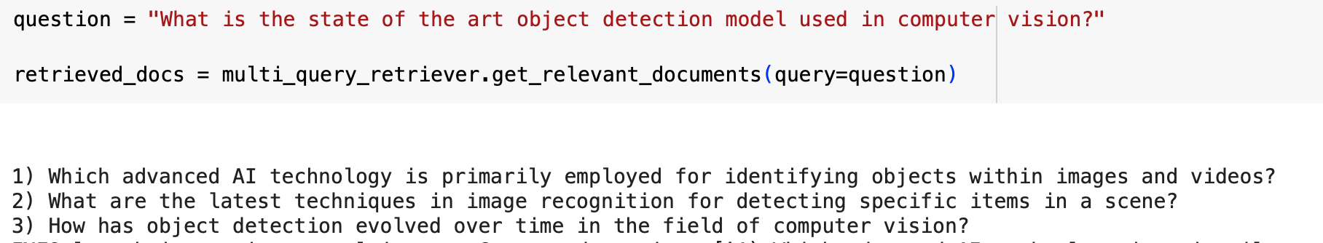

Figure 3: An Example of Query Expansion

For each generated query, it retrieves relevant documents and then amalgamates these sets to form a comprehensive collection of pertinent documents. By encompassing diverse viewpoints on a single query, the MultiQuery Retriever aims to surmount some limitations of distance-based retrieval, potentially yielding a more enriched set of results. Additionally, we experimented with two types of retrievers for the MultiQuery Retriever: Maximum Marginal Relevance Retrieval (MMR) and similarity search.

### Evaluation

Through evaluation, we aim to find the best-performed combination of the two elements:

* vector stores encoded by different embedding models with/without newline characters as shown above
* retrieval methods as mentioned above

#### Methodology used to label the retrieved documents

20 queries[1] were generated for the evaluation purpose. For every query, we retrieve five documents using different pairs of vector stores and retrievers. These documents are then labeled using two methods: manual labeling by human reviewers and automated labeling by Large Language Models (LLMs).

##### LLM Labeling

We utilized Vicuna-7b-v1.5 to determine the relevance of each retrieved document to its corresponding query. To facilitate this determination, we employed a specific prompt template for the LLM. The template is structured as follows:

prompt = f"Document: {doc}\n\n Question: {qns}\n\n The document is retrieved based on the question. Is the document relevant to the question? Please answer YES or NO"

In this template, {doc}represents the text of the retrieved document, and{qns}}refers to the query or question based on which the document was retrieved.

For each document-query pair, we posed the question to the LLM three times to ascertain the relevance of the document to the query. The final label for each document was determined based on a majority vote system. Out of the three responses obtained from the LLM for each document-query pair, the most frequently occurring response (either 'YES' or 'NO') was chosen as the final label. This majority vote approach provides a robust measure against any potential anomalies or biases in single responses, as well as the unstableness of LLM generation.

##### Manual Labeling

Steps:

1. “1” to mark the retrieved paper as ‘relevant’
2. “0” to label ‘not relevant’ for those who do not sufficiently address the query
3. Start another N rounds of labeling and take the majority vote

Example of labeling: relevances of documents on 20 queries are stored in a list of lists. Each sub-list represents the relevance result of one query. Each label in the sub-list represents the relevance of a retrieved document to the query.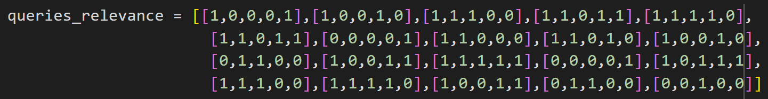

Figure 4: Example of labeling

#### Evaluation Metrics

In the experiment, we have used a comprehensive set of metrics to evaluate the performance of the retrieval system. The metrics used are as follows:

* Mean Average Precision(mAP)
* Mean Reciprocal Rank(mRR)
* Mean Discounted Cumulative Gain(mDCG)
* Mean Normalized Discounted Cumulative Gain(mNDCG)

#### Results

|  | all-mpnet-base-v2 (with newline) | all-mpnet-base-v2  (without newline) | BAAI/bge-small-en-v1.5 (with newline) | BAAI/bge-small-en-v1.5  (without newline) | all-MiniLM-L6-v2 (with newline) | all-MiniLM-L6-v2  (without newline) | BAAI/bge-base-en-v1.5 (with newline) | BAAI/bge-base-en-v1.5 (without newline) |
| --- | --- | --- | --- | --- | --- | --- | --- | --- |
| mAP | 0.712 | 0.757 | 0.848 | 0.821 | 0.816 | 0.756 | 0.750 | 0.816 |
| mRR | 0.783 | 0.858 | 0.910 | 0.879 | 0.910 | 0.792 | 0.837 | 0.863 |
| mDCG | 1.978 | 2.109 | 2.295 | 2.035 | 2.085 | 2.122 | 2.053 | 2.024 |
| mNDCG | 0.815 | 0.817 | 0.890 | 0.895 | 0.870 | 0.802 | 0.822 | 0.878 |
| Overall Performance | 1.072 | 1.135 | 1.236 | 1.157 | 1.170 | 1.118 | 1.115 | 1.145 |

Table 3: Evaluation of Embedding Models with Similarity Search   
using Labels Generated by Humans

|  | BM25 | MMR | Multiquery | Multiquery_MMR | Similarity Search |
| --- | --- | --- | --- | --- | --- |
| mAP | 0.617 | 0.620 | 0.603 | 0.590 | 0.648 |
| mRR | 0.633 | 0.617 | 0.629 | 0.620 | 0.692 |
| mDCG | 1.393 | 1.762 | 1.584 | 1.576 | 1.716 |
| mNDCG | 0.719 | 0.768 | 0.692 | 0.715 | 0.711 |
| Overall Performance | 0.840 | 0.941 | 0.877 | 0.875 | 0.942 |

Table 4: Evaluation of Retrievers with the Vector Database   
BAAI/bge-small-en-v1.5 (with newline) using Labels Generated by LLMs

#### Analysis of Evaluation Result

By providing an equal weight to each metric, we calculated the overall performance for each embedding model and retrieval method. It was observed that removing newline characters in the vector store does not generate better performance in general. And we can draw the following conclusions:

1. The vector store encoded by embedding model *BAAI/bge-small-en-v1.5* with newline characters provides the best performance among all vector stores.
2. Maximum Marginal Relevance retrieval is the best among the 4 retrieval methods.

## 

## 4. Generation Using LLM

In this section, responses will be generated using an LLM, with different temperatures and different prompting techniques. We will evaluate the performance of each LLM and select the best.

### LLM Selection Rationale

In the pursuit of an optimal Language Model (LLM) for our information retrieval project, we faced a critical constraint: limited computational resources. Our project's infrastructure, particularly in terms of available GPU VRAM, necessitated a careful selection of models that could efficiently operate within these confines.

Consequently, our focus was directed towards 7B parameter models. These models strike a balance between sophisticated language understanding capabilities and a computational footprint that aligns with our resource availability. This balance is crucial, as it allows for the deployment and operation of these models without overwhelming our hardware, ensuring consistent performance and stability throughout the project.

In the end, we selected 3 fine-tuned versions of Mistral-7B (Jiang et al., 2023) due to the base model’s robust capabilities, outperforming all other 7B models on the Open LLM Leaderboard (Gao et al., 2021). Some fine-tuned versions of Mistral-7B are even able to surpass larger models like LLaMA 2 70B in certain aspects (Lian et al., 2023), showcasing its efficiency and power even within the 7B parameter range.

### Selected LLMs

1. Open-Orca/Mistral-7B-OpenOrca (Lian et al., 2023)

* Overview: Mistral-7B-OpenOrca is an instruction-tuned version of Mistral-7b, renowned for its ability to precisely interpret and execute complex instructions.
* Reason for Selection:
  + Instruction Tuning: Its capability to follow specific instructions accurately is vital for targeted information retrieval tasks.
  + Local Deployment: This model's compatibility with consumer-grade hardware offers significant flexibility in resource utilization, as demonstrated in the Troyanovsky/Local-LLM-Comparison-Colab-UI GitHub repository.
  + Practical Evaluation: The Colab WebUI interface permits direct performance comparisons with other LLMs, providing tangible insights into its effectiveness.

1. Intel/neural-chat-7b-v3-1 (Intel, 2023)
   * Overview: A fine-tuned iteration of mistralai/Mistral-7B-v0.1, based on the Open-Orca/SlimOrca dataset and aligned with the DPO algorithm.
   * Reason for Selection:
     + Open Source Data Fine-tuning: Leveraging the Open-Orca/SlimOrca dataset ensures a broad and diverse data foundation, enhancing adaptability and understanding.
     + DPO Algorithm Alignment: The incorporation of the DPO algorithm likely augments the model’s efficiency in information processing and retrieval.
2. fblgit/juanako-7b-UNA (Murias, 2023)
   * Overview: An advancement of intel/neural-chat-7b-v3-1, juanako-7b-UNA uses the HuggingFaceH4/ultrafeedback_binarized dataset and incorporates Uniform Neural Alignment (UNA).
   * Reason for Selection:
     + Top-tier Truthful QA Performance: This model stands out for its accuracy and reliability in responses, especially among 7b parameter LLMs.
     + UNA Implementation: UNA likely enhances the model's consistency and coherence, making it highly effective for complex information retrieval tasks.

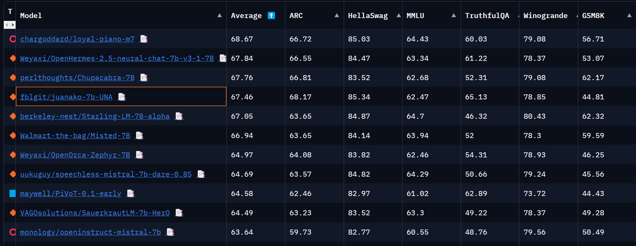

Figure 5: Open LLM Leaderboard (4 December 2023)

### Generation Methodology

The primary objective of our testing methodology was to comprehensively assess the performance of the selected LLMs in responding to complex questions in the field of computer science. This was achieved by experimenting with different temperatures and prompting methods.

1. **Temperature Settings**:
   1. Each LLM was tested across a range of temperature settings: {0, 0.25, 0.5, 0.75, 1}.
   2. Temperature, in the context of LLMs, influences the model's randomness in generating responses. A lower temperature leads to more predictable and conservative outputs, while a higher temperature fosters creativity and variability (Saleem, 2023).
2. **Prompting Methods[2]**:
   1. Four distinct prompting methods were employed to evaluate the LLMs:
      1. Vanilla: The LLM was given the question directly without any modifications to the prompt.
      2. Chain of Though (CoT): This approach involves prompting the LLM to elaborate on its thought process, laying out the reasoning behind its answer (Wang et al., 2023).
      3. Tree of Thoughts (ToT): An extension of the Chain of Thought, this method prompts the LLM to explore multiple reasoning pathways before concluding (Yao et al., 2023).
      4. Role Playing: The LLM was asked to role-play as an expert in computer science and answer the questions, potentially leading to responses that are more authoritative and specialized (Ramlochan, 2023).
3. **Question Source and Selection[3]**:
   1. The questions for the evaluation were sourced from arXiv papers in our dataset, spanning the years 2021 to 2023.
   2. A curated list of 20 questions was created, accompanied by corresponding answers. This list served as a standardized benchmark to evaluate the performance of each LLM.

### LLM Output Analysis[4]

In this section, qualitative analysis will be conducted on the outputs[5] from the LLMs.

Firstly, the effects of temperature on the output of the LLM are evaluated. A lower temperature value tends to cause the LLM to return a more detailed and complex answer. As temperature values increase, the detail and complexity of the answers vary, and the LLM starts to produce answers that include other concepts related to the question. At higher temperatures, the answer becomes more general and focuses less on the in-depth technical aspects. Additionally, it was observed that at temperatures of both extremes, 0 and 1, the LLM is more likely to generate an empty response, particularly for Mistral-7B-OpenOrca.

Secondly, a comparison between the outputs of each LLM was carried out. Here are the observations:

* Juanako-7b-UNA provides a detailed, technical insight into the subject, ideal for a technically proficient audience.
* Neural-Chat-3-1 adopts a more practical approach, emphasizing the benefits of specific applications (like gaming), making it more accessible to a general audience.
* Mistral-7B-OpenOrca bridges the gap between detailed technical explanation and practical application, providing a thorough understanding while also highlighting real-world implications.

Each model presents the information differently, catering to varying levels of technical expertise and interest areas. However, we found that Mistral-7B-OpenOrca aligns with the objective of our problem statement the best.

Lastly, the results of using different prompting methods are analyzed, and here are the observations:

* CoT and ToT are more detailed and thorough compared to Vanilla and Role-playing.
* ToT offers the most comprehensive analysis by covering multiple aspects from different perspectives.
* Vanilla is the most straightforward, making it suitable for a quick and clear understanding.
* LLMs are way more likely to return an empty response with Vanilla prompting

## 5. Verification of LLM Output Using Retrieved Documents

For the verification of the previously generated LLM output using the retrieved documents, we experimented with a few different techniques:

1. Using an LLM to verify if the output matches the content of the documents
   1. Vanilla
   2. CoT
   3. ToT
   4. Self-consistent Vanilla
   5. Self-consistent CoT
   6. Self-consistent ToT
2. Using Rouge score to evaluate how similar the LLM response and the retrieved documents are.
3. Using Meteor score to evaluate how closely the LLM generated output aligns with the retrieved documents.
4. Using Bleu score to evaluate how similar the LLM response is to the retrieved documents.

### Using an LLM to Verify if the Output Matches the Content of the Documents

The methodology used to verify the LLM-generated output by using an LLM and the retrieved documents are as follows:

1. For each question, retrieve the top 5 relevant documents using the best retrieval combination of:
   1. bge-small-en-v1.5 embedding
   2. Chromadb
   3. Similarity search
2. Combine the LLM-generated output and the top 5 relevant documents into the prompt template[6] corresponding to the verification method.
3. Use the generated prompt to call the LLM and obtain the answer.
4. Conduct some data processing to convert the LLM’s response into a standardized format for analysis.

The results of the verification method against the different prompting methods are shown in Table 3, whereby the values in the table is the percentage of verified responses.

|  | Vanilla Response | CoT Response | Role Playing Response | ToT Response |
| --- | --- | --- | --- | --- |
| Vanilla LLM Verification | 72.05% | 72.67% | 71.67% | 75.00% |
| CoT LLM Verification | 73.40% | 79.33% | 78.33% | 80.33% |
| ToT LLM Verification | 65.67% | 67.33% | 65.33% | 68.67% |
| Vanilla Self Consistent Verification | 75.76% | 70.00% | 69.67% | 71.33% |
| CoT Self Consistent Verification | 74.32% | 79.03% | 75.47% | 79.88% |
| ToT Self Consistent Verification | 65.27% | 66.34% | 64.61% | 67.63% |

Table 5: Table containing the average verified LLM outputs for each prompting type and verification method.

A more interesting result can be obtained by calculating the average verified response percentage for each LLM.

| juanako-7b-UNA | neural-chat-7b-v3-1 | Mistral-7B-OpenOrca |
| --- | --- | --- |
| 74.70 | 76.76 | 76.90 |

Table 6: The average percentage of verified outputs for each LLM

The findings from Table 4 suggest that Mistral-7B-OpenOrca may be the best when generating responses without any relevant documents added to the prompt.

### Using Various Score Metrics to Verify if the LLM Generated Output Matches the Content of the Documents

In addition to using LLMs to verify if an LLM generated output is correct, we also tried using various scores such as BLEU, Rouge, BERT and METEOR.

* BERT Score: leverages the pre-trained contextual embeddings from BERT and matches words in candidate and reference sentences by cosine similarity.
  + take the mean of precision, mean of recall, and mean of f1
* BLEU (Bilingual Evaluation Understudy): an algorithm for evaluating the quality of text that has been machine-translated from one natural language to another.
  + BLEU sore and mean of precisions
* Rouge (Recall-Oriented Understudy for Gisting Evaluation): a set of metrics and a software package used for evaluating automatic summarization and machine translation software in natural language processing. The metrics compare an automatically produced summary or translation against a reference or a set of references (human-produced) summary or translation. It is case insensitive.
  + rouge1: unigram (1-gram) based scoring
  + rouge2: bigram (2-gram) based scoring
  + rougeL: Longest common subsequence-based scoring.
  + rougeLSum: splits text using "\n"
* METEOR (Metric for Evaluation of Translation with Explicit ORdering): a machine translation evaluation metric, which is calculated based on the harmonic mean of precision and recall, with recall weighted more than precision.
  + meteor score

The results of our analysis showed very little difference in the scores for each metric, illustrated by the standard deviation of the scores in Table 7. As such, it is very difficult to find a suitable threshold to label whether a document is verified based on its score and the score metrics were deemed ineffective for verifying if an LLM-generated output matches the semantic meaning of the retrieved documents.

| Vanilla BLEU Score | Vanilla ROUGE Score | CoT BLEU Score | CoT ROUGE Score | Role Playing BLEU Score | Role Playing ROUGE Score | ToT BLEU Score | ToT ROUGE Score |
| --- | --- | --- | --- | --- | --- | --- | --- |
| 0.0377 | 0.0389 | 0.0377 | 0.0412 | 0.0406 | 0.0416 | 0.0284 | 0.0409 |

Table 7: The standard deviation of all the scores across the 3 LLMs and 5 temperatures.

## 6. Generation of Citations for Verified LLM Output.

## 

Figure 6: Overview of the LLM generation process with grounding from retrieved documents, but without in-context learning.

To generate citations for a verified LLM output, we use an LLM to pick the relevant documents and create citations.

Our research in finding the best way to generate citations necessitated the division of the citation process into two parts, related documents retrieval and LLM citation generation, and experiment with different method combinations respectively.

Through our previous findings, we found out that using the vector database’s similarity search produces the best results, Thus we decided to use the vector database as the document retriever and similarity search as the search algorithm.

For LLM citation generation, we used neural-chat-7b with a role-playing prompt method by telling the LLM it is a computer science expert. Subsequently, we asked it to generate APA format citations using the provided relevant documents and questions. We experimented with different LLM temperatures with different prompts, getting the best result from the temperature of 0.75 with an example of APA citation in the prompt (1-shot prompting).

The example below details the experimental results:

* temperature = 0: not generating citations at all, LLM simply repeated provided questions and documents.
* temperature = 0.75: generated citations did not follow APA style all the way as stated in the prompt, but citations basically aligned with the source.
* temperature = 0.75 + example of APA citation in the prompt: generated citations followed APA style most of the time as well as satisfying correctness. It has the best performance overall (refer to Figure 6 for an example).

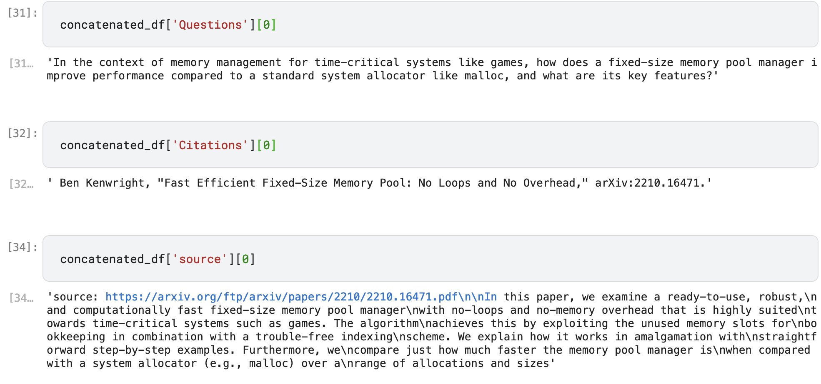

Figure 7: Example Results of Citation Generation with an LLM

## 

## 7. LLM Generation using RAG

Using all the learnings from the previous sections, the final Retrieval Augmented Generation (RAG) system utilizes the pipeline shown in Figure 7 to generate the final output.

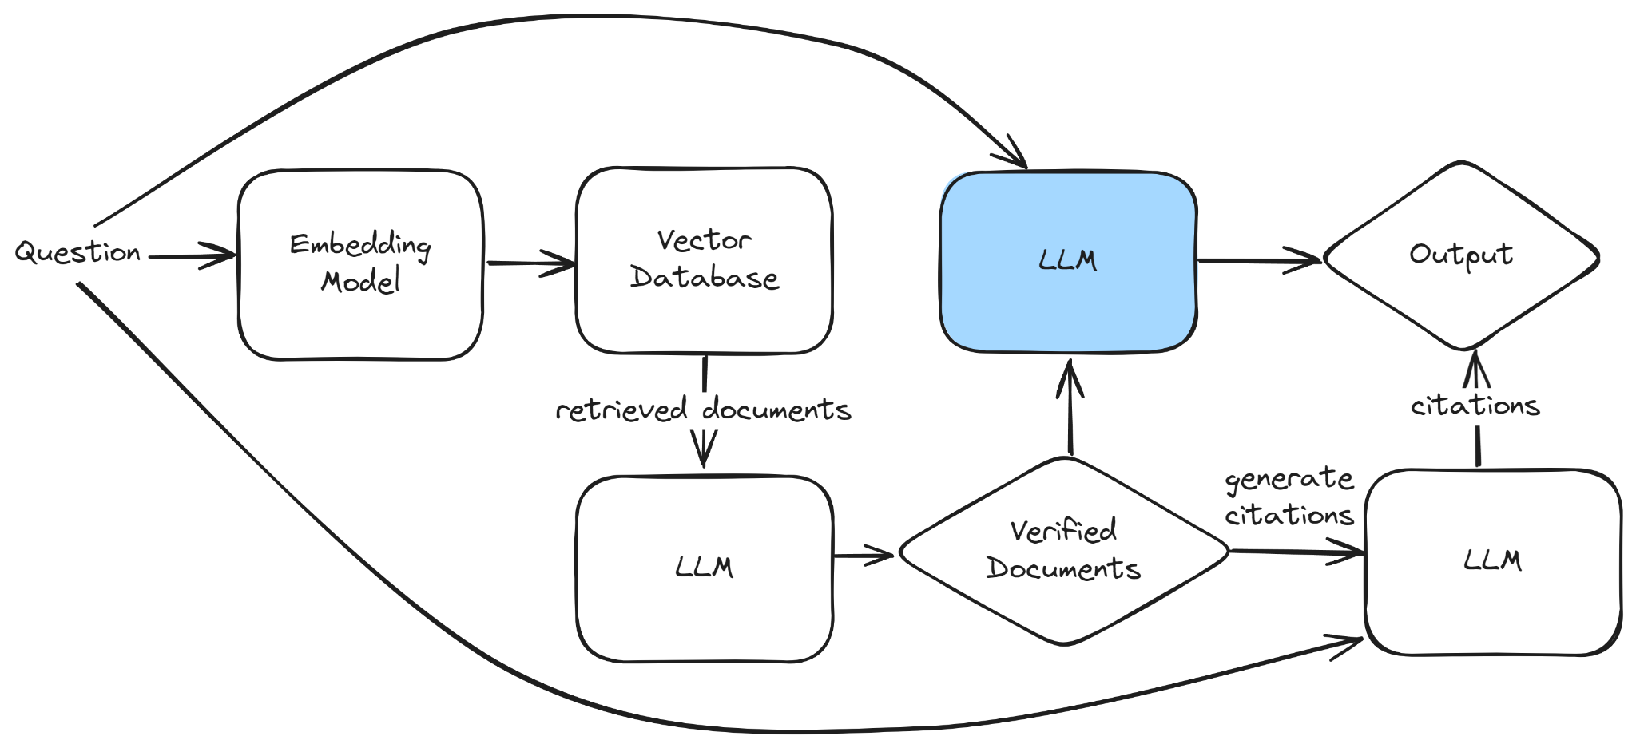

Figure 8: The RAG pipeline used to generate the output for AIxplorer.

In our document retrieval setup, we will employ ChromaDB and bge-small-en-v1.5 for indexing and retrieval, complemented by a similarity search algorithm to retrieve the top 5 relevant documents.

Additionally, we conducted experiments by varying the parameters of the LLM, as illustrated with a blue background in Figure 7. These experiments will focus on adjusting the temperature settings of the LLMs, employing different prompting strategies[7], and experimenting with different LLMs. The effectiveness of each combination of these components will be thoroughly evaluated in Section 10. Based on this evaluation[8], we aim to identify and implement the most effective combination to enhance the accuracy of our Retrieval-Augmented Generation (RAG) system.

## 8. LLM Performance Evaluation without RAG

To evaluate the performance of LLM, we prepared 20 questions and answers from the CS paper database. The questions are examined to make sure that the answer can be found in the curated database so that theoretically LLM is capable of finding answers in retrieved chunks and annotating with the source citation as well.

We used two approaches to evaluate the performance of LLM: one is to calculate different scores from the evaluation package, and the other is using another LLM to evaluate the performance of LLM.

To compute the scores for each metric, we used the 20 prepared questions, combined with our human-annotated answers for the questions, and compared the LLM-generated output with the human-annotated answer.

##### Results

| Metric | BertScore | | | Bleu Score | | Rouge Score | | | | Meteor |
| --- | --- | --- | --- | --- | --- | --- | --- | --- | --- | --- |
|  | Precision | F1 | Recall | Bleu | Precision | Rouge1 | Rouge2 | RougeL | RougeLsum | Meteor |
| max score | 0.8712 | 0.8561 | 0.8481 | 0.0798 | 0.2020 | 0.3793 | 0.1407 | 0.2103 | 0.3405 | 0.2742 |
| LLM combination | LLMA, temp= 0.5, RP | LLMA, temp=0.5, RP | LLMA, temp=0.25, RP | LLMA, temp=0, RP | LLMA, temp= 0.5, RP | LLMA, temp= 0.75, RP | LLMA, temp= 0.5, RP | LLMA, temp= 0.5, RP | LLMA, temp= 0.75, RP | LLMA, temp= 1, CoT |

Table 8: Highest scores achieved for each metric when generating using an LLM without RAG, LLMA = Mistral-7B-OpenOrca, RP = Role Play.

#### LLM Evaluation

In terms of using another LLM to evaluate the performance of the first LLM, we provide questions, generated responses, and ground truths to LLM. Using the role-playing prompt method, we tell LLM it is a teacher whose job is to mark student’s answers. It was asked to decide whether the response matches the ground truth, if yes, output ‘yes’, otherwise output ‘no’. We experimented with three LLMs explored, Mistral-7B-OpenOrca, neural-chat-7b-v3-1, and juanako-7b-UNA. To conduct the evaluation, we then carried out a voting of their marks, if the number of ‘yes’ >= 2, then it is considered a match, and vice versa.

##### Results

| Vanilla | Chain of Thought | Role Playing | Tree of Thoughts |
| --- | --- | --- | --- |
| 45 | 69 | 63 | 56 |

Table 9: The total number of “yes” for each prompting method used to generate an answer without RAG

As shown above, Table 9 aggregates the total count of "yes" responses for each of the four prompting methods across all combinations of LLMs and temperature settings. Notably, the Chain of Thought prompting method emerges as the most effective, receiving a total of 69 affirmations from the LLM, the highest among all methods evaluated.

|  | juanako-7b-UNA | Mistral-7B-OpenOrca | neural-chat-7b-v3-1 |
| --- | --- | --- | --- |
| Vanilla | 19 | 17 | 9 |
| Chain of Thoughts | 25 | 16 | 28 |
| Role Playing | 19 | 23 | 21 |
| Tree of Thoughts | 18 | 22 | 16 |
| **Total** | **81** | **78** | **74** |

Table 10: The total number of “yes” for each LLM output without RAG, broken down by the prompting methods.

In table 10, we can see that the juanako-7b-UNA performed the best when the number of “yes” is aggregated across all the temperatures and voting methods.

|  | Temperature | | | | |
| --- | --- | --- | --- | --- | --- |
| 0.0 | 0.25 | 0.5 | 0.75 | 1.0 |
| Vanilla | 19 | 25 | 23 | 18 | 25 |
| Chain of Thoughts | 19 | 18 | 25 | 23 | 25 |
| Role Playing | 19 | 21 | 23 | 19 | 18 |
| Tree of Thoughts | 17 | 21 | 16 | 17 | 19 |
| **Total** | **74** | **85** | **87** | **77** | **87** |

Table 11: The total number of “yes” for each LLM output without RAG, broken down by the prompting methods.

Table 11 shows better performance arises from temperature = 1.0 and temperature = 0.5 when the number of “yes” is aggregated across all the LLMs.

Given the results from Table 9, 10, 11, The best combination to generate a response without RAG, using a greedy approach would be to pick the best performing method from each of the previously mentioned tables: CoT, juanako-7b-UNA and temperature = 0.5.

However, upon closer scrutiny of the individual combination performances, we found out that the best combination picked using a greedy approach did not give us the true top performer. The maximum number of “yes” which hits 10 out of 20 questions is Mistral-7B-OpenOrca with a temperature of 0.75, using the Tree of Thought prompting method. It reached a correctness of 0.5 ratio, which outperformed other parameter combinations.

#### Analysis of Evaluation Results

From the above results, we can see clearly that Mistral-7B-OpenOrca has the best performance of all metrics. The best LLM combination evaluated by score metrics is temperature = 0.5 with the role-playing prompting method, while temperature = 0.75 with the Tree of Thought prompting method has the best correctness ratio of 0.5 based on LLM evaluation.

## 9. LLM Performance Evaluation with RAG

Following the same techniques used for LLM performance without RAG, we conduct the evaluation again for LLM performance with RAG.

#### Results for Score Metrics

| Metric | BertScore | | | Bleu Score | | Rouge Score | | | | Meteor |
| --- | --- | --- | --- | --- | --- | --- | --- | --- | --- | --- |
|  | Precision | F1 | Recall | Bleu | Precision | Rouge1 | Rouge2 | RougeL | RougeLsum | Meteor |
| max score | 0.8806 | 0.8912 | 0.8791 | 0.2093 | 0.2143 | 0.3944 | 0.2640 | 0.3206 | 0.3323 | 0.4718 |
| LLM combination | LLMB, temp=1, CoT | LLMB, temp=1, RP | LLMB, temp=1, RP | LLMC, temp=0, RP | LLMC, temp=0, RP | LLMC, temp= 0.25, RP | LLMC, temp=0, RP | LLMC, temp=0, RP | LLMC, temp=0, RP | LLMC, temp=0, RP |

Table 12: Highest scores achieved for each metric when generating using an LLM with RAG, LLMB = neural-chat-7b, LLMC = juanako-7b, RP = Role Play

#### Results for LLM Self-Evaluation

| Vanilla | Chain of Thought | Role Playing | Tree of Thoughts |
| --- | --- | --- | --- |
| 110 | 110 | 100 | 90 |

Table 13: The total number of “yes” for each prompting method used to generate an answer with RAG

By summing the votes that are correct of each prompting method up, we can see that Vanilla ties with Chain of Thought.

|  | juanako-7b-UNA | Mistral-7B-OpenOrca | neural-chat-7b-v3-1 |
| --- | --- | --- | --- |
| Vanilla | 41 | 34 | 35 |
| Chain of Thought | 39 | 42 | 29 |
| Role Playing | 33 | 30 | 37 |
| Tree of Thoughts | 32 | 27 | 31 |
| **Total** | **145** | **133** | **132** |

Table 14: The total number of “yes” for each LLM output with RAG, broken down by the prompting methods.

Categorizing the correct votes of each model with the prompting method, we can see that juanako-7b-UNA is the best choice.

|  | Temperature | | | | |
| --- | --- | --- | --- | --- | --- |
| 0.0 | 0.25 | 0.5 | 0.75 | 1.0 |
| Vanilla | 10 | 7 | 12 | 7 | 12 |
| Chain of Thoughts | 15 | 9 | 13 | 15 | 13 |
| Role Playing | 12 | 11 | 14 | 15 | 14 |
| Tree of Thoughts | 9 | 9 | 11 | 16 | 11 |
| **Total** | **46** | **36** | **50** | **53** | **50** |

Table 15: The total number of “yes” for each LLM output with RAG, broken down by the prompting methods.

As indicated in Table 15, it is observed better performance is achieved when temperature = 0.75.

Using the results from Tables 13, 14, 15, to choose the best combination to generate response with RAG greedily, we can select CoT, juanako-7b-UNA and temperature = 0.75 as the best performing combination.

However, once again, if we analyze the individual performance of each combination, we realise that the above mentioned combination does not perform the best. The best performer is actually Mistral-7B-OpenOrca with 1.0 temperature, Chain of Thought prompting method and neural_chat_3.1 with 0.5 temperature, Chain of Thought prompt both achieved 11 matches out of 20, which is an improvement compared to the 0.5 success ratio of LLM performance without RAG.

#### Analysis of Evaluation Results

Compared to the evaluation of LLM performance without RAG, we can see that all of the scores have increased with RAG, as well as response vote success rates. Among all models and parameters, juanako-7b with a temperature of 0 with the role-playing prompting method performed the best with regards to the score metrics, while Mistral-7B-OpenOrca of 1.0 temperature with Chain of Thought prompting method and neural_chat_3.1 of 0.5 temperature with Chain of Thought prompting method has the best performance in LLM self-evaluation.

## 

## 10. Conclusion

In conclusion, our research has introduced a Retrieval Augmented Generation (RAG) system optimized for the computer science research environment. This tailored system integrates the information retrieval capabilities of a specialized paper retrieval component with the sophistication of Large Language Models (LLMs). By sourcing relevant papers through an external database and augmenting LLM analysis with up-to-date documents, our approach has significantly improved researchers' ability to locate specific papers without being overwhelmed by the sheer volume of available data.

The development and refinement of this RAG system involved a meticulous dataset construction process harvested from arXiv, the use of advanced text-splitting techniques, and the selection of optimal vector stores and retrievers. Comparative evaluations of various retrieval techniques and embedding models highlighted the strength of the model BAAI/bge-small-en-v1.5 and the effectiveness of the Cosine Similarity Search.

Further examination into the generation capabilities of various LLMs, including Mistral-7B and its fine-tuned counterparts, revealed the nuanced differences in their performance based on temperature settings and prompting methods. Our experimental evaluation verified that the considered LLMs return highly technical, diverse, and context-rich output, especially when leveraging sophisticated prompting strategies such as Chains of Thought (CoT) and Trees of Thought (ToT).

The incorporation of RAG into the question-answering framework was instrumental in enhancing the LLMs' ability to generate concise, relevant, and verified academic responses. Notably, incorporating ChromaDB for document retrieval in conjunction with similarity search algorithms proved effective in facilitating the source of ground truths for generation verification.

The generation trials revealed that specific combinations of prompting methods and temperature configurations of LLMs such as Mistral-7B-OpenOrca lead to significantly enhanced output performance. By incorporating RAG into our LLMs, we observed noticeable improvements in both metric-driven evaluations and self-evaluation by LLMs.

Ultimately, the RAG system we propose stands as a progressive solution to the challenges encountered in academic paper searches within computer science. Through comprehensive evaluations, we have identified the best-performing combinations of vector databases, retrievers, and LLM parameters. The resulting RAG system, featuring a synergetic blend of retrieval and generation processes, offers a scalable, efficient, and accurate tool for researchers seeking to navigate the extensive corpus of academic literature. This work sets the stage for future developments and the continual evolution of tools designed to streamline the research process in the fast-paced, ever-growing field of computer science.

## 11. References

Intel. (2023). *Intel/neural-chat-7b-v3-1 · Hugging Face*. Hugging Face. Retrieved December 4, 2023, from https://huggingface.co/Intel/neural-chat-7b-v3-1

Jiang, A. Q., Sablayrolles, A., Mensch, A., Bamford, C., Chaplot, D. S., Casas, D. d. l., Bressand, F., Lengyel, G., Lample, G., Saulnier, L., Lavaud, L. R., Lachaux, M.-A., Stock, P., Scao, T. L., Lavril, T., Wang, T., Lacroix, T., & Sayed, W. E. (2023). Mistral 7B. *arXiv preprint*, *arXiv:2310.06825.* https://arxiv.org/abs/2310.06825

Lian, W., Goodson, B., Wang, G., Pentland, E., Cook, A., Vong, C., & Teknium. (2023, October 21). *MistralOrca: Mistral-7B Model Instruct-tuned on Filtered OpenOrcaV1 GPT-4 Dataset*. Hugging Face. Retrieved December 4, 2023, from https://huggingface.co/Open-Orca/Mistral-7B-OpenOrca

Leo Gao, Jonathan Tow, Biderman, S., Black, S., DiPofi, A., Foster, C., Golding, L., Hsu, J., McDonell, K., Muennighoff, N., Phang, J., Reynolds, L., Tang, E., Thite, A., Wang, B., Wang, K., & Zou, A. (2021). A framework for few-shot language model evaluation (v0.0.1). Zenodo. <https://doi.org/10.5281/zenodo.5371629>

Murias, X. (2023, October 27). *fblgit/juanako-7b-UNA · Hugging Face*. Hugging Face. Retrieved December 4, 2023, from https://huggingface.co/fblgit/juanako-7b-UNA

Ramlochan, S. (2023, May 27). *Role-Playing in Large Language Models like ChatGPT*. The Prompt Engineering Institute. Retrieved December 4, 2023, from https://promptengineering.org/role-playing-in-large-language-models-like-chatgpt/

Saleem, A. (2023, September 11). *How to tune LLM Parameters for optimal performance*. Data Science Dojo. Retrieved December 4, 2023, from https://datasciencedojo.com/blog/llm-parameters/#

Wang, B., Min, S., Deng, X., Shen, J., Wu, Y., Zettlemoyer, L., & Sun, H. (2023). Towards Understanding Chain-of-Thought Prompting: An Empirical Study of What Matters. *ACL Anthology*, *Proceedings of the 61st Annual Meeting of the Association for Computational Linguistics (Volume 1: Long Papers)*, 2717–2739. https://aclanthology.org/2023.acl-long.153

Yao, S., Yu, D., Zhao, J., Shafran, I., Griffiths, T. L., Cao, Y., & Narasimhan, K. (2023). Tree of Thoughts: Deliberate Problem Solving with Large Language Models. *arXiv preprint*, *arXiv:2305.10601*. https://arxiv.org/abs/2305.10601

## 12. Appendix

### Appendix A

List of questions for retrieval performance evaluation:

1. What are the latest trends in artificial intelligence for healthcare?
2. How is machine learning being applied to improve cybersecurity?
3. What advancements have been made in quantum computing in the last five years?
4. How are deep learning techniques revolutionizing natural language processing?
5. What are the ethical implications of facial recognition technology?
6. How is blockchain technology being utilized beyond cryptocurrencies?
7. What are the challenges in scaling big data analytics?
8. How has the Internet of Things (IoT) evolved in smart city applications?
9. What are the latest developments in augmented reality and virtual reality?
10. How is cloud computing transforming enterprise IT infrastructure?
11. What breakthroughs have been made in autonomous vehicle technology?
12. What are the current challenges in 5G network implementation?
13. How is robotics being integrated into manufacturing processes?
14. How is computer vision being applied in environmental monitoring?
15. What new programming paradigms are emerging in software development?
16. How are genetic algorithms being used in optimization problems?
17. What are the recent advancements in database management systems?
18. How is reinforcement learning being applied in gaming and simulations?
19. How are graph neural networks being used in social network analysis?
20. What are the innovations in energy-efficient computing?

### 

### Appendix B

Vanilla LLM generation prompt template:

{question}

Chain of Thoughts LLM generation prompt template:

{question}

Please think step by step

Role Playing LLM generation prompt template:

You are a helpful bot whose expertise lies in the field of computer science.

Please answer the question below to the best of your ability:

{question}

Tree of Thoughts LLM generation prompt template:

Imagine three different experts are answering this question.

All experts will write down 1 step of their thinking,

then share it with the group.

Then all experts will go on to the next step, etc.

If any expert realises they're wrong at any point then they leave.

The question is: {question}

### 

### Appendix C

List of questions and human annotated answers for LLM output evaluation:

1. In the context of memory management for time-critical systems like games, how does a fixed-size memory pool manager improve performance compared to a standard system allocator like malloc, and what are its key features?

A fixed-size memory pool manager significantly improves performance in time-critical systems, such as games, by providing faster memory allocations and de-allocations. This is achieved through a no-loops and no-memory overhead design, which utilizes unused memory slots for bookkeeping combined with an efficient indexing scheme. Key features of this memory pool manager include:

Speed: It offers a much faster alternative compared to standard system allocators (like malloc) due to its efficient design.

No Loops and No Recursive Functions: This design choice reduces the computational overhead, making the algorithm faster.

Minimal Initialization Overhead: Only the first element in the memory pool is initialized, reducing the time and computational resources needed for initialization.

Low Memory Footprint: The memory pool manager uses a few dozen bytes, making it efficient in terms of memory usage.

No-Fragmentation: It effectively minimizes memory fragmentation, a common issue in dynamic memory allocation.

Simplicity and Portability: The algorithm is straightforward, easy to understand, and can be implemented in various systems, including those with high-speed requirements.

1. In the context of decision-making in artificial agents, explain the concept of "satisficing" and how it relates to resource-rational analysis using information-theoretic and rate-distortion theory models.

"Satisficing" is a concept in decision-making, particularly in the study of artificial and biological agents, which refers to the pursuit of solutions or policies that are sufficiently satisfactory under limited resources, rather than seeking the optimal solution. This approach is significant in environments with overwhelming complexity where agents face constraints on cognitive or computational resources. In resource-rational analysis, this concept is framed within utility-theoretic and information-theoretic models. The latter uses rate-distortion theory to model decision-making behaviors as communication channels with a bounded rate constraint. This means the agent seeks to maximize returns or performance while transmitting the minimum amount of information possible, operating within the confines of its information-processing capabilities. Such models help in formalizing capacity-limited decision-making and are crucial in developing learning algorithms that efficiently balance the trade-offs between resource constraints and decision-making efficacy.

1. In the context of point cloud segmentation, what is the primary innovation of the Multimodal Interlaced Transformer (MIT), and how does it improve weakly supervised point cloud segmentation compared to traditional methods?

The Multimodal Interlaced Transformer (MIT) introduces a novel approach for weakly supervised point cloud segmentation by effectively fusing 2D and 3D data without requiring additional 2D annotations. Traditional methods in this field typically rely on either 2D or 3D data separately or require extra annotations for effective data fusion. The MIT, however, utilizes a transformer model with two encoders and one decoder to process 3D point clouds and 2D multi-view images concurrently, leveraging only scene-level class tags. This approach allows for implicit fusion of 2D and 3D features through an interlaced 2D-3D cross-attention mechanism in the decoder, enhancing the feature enrichment process iteratively. As a result, MIT can achieve improved point cloud segmentation performance in a weakly supervised learning context, significantly reducing the annotation burden while leveraging the complementary strengths of both 2D texture clues and 3D geometric features.

1. Explain the principle of Over-the-Air (OtA) computation in distributed systems and how it differs from traditional digital communication in terms of resource efficiency.

"Over-the-Air (OtA) computation, also known as AirComp, is an approach used in distributed systems, particularly in the context of Internet-of-Things (IoT) and wireless networks, to efficiently aggregate data and perform distributed computations. The core principle of OtA computation is to leverage the superposition property of electromagnetic waves in the analog domain. In a wireless multiple-access channel, signals sent by different devices naturally add up 'in the air', enabling simultaneous data transmission from multiple nodes. This process differs from traditional digital communication, which typically assigns orthogonal resources (like frequency or time slots) to each device for data transmission, leading to potential inefficiencies, especially in systems with a large number of devices.

In OtA computation, instead of sending and receiving data individually from each node, the combined signal is received and processed to compute functions such as arithmetic mean, geometric mean, or Euclidean norm. This method saves significant spectrum resources as it allows all devices to transmit data simultaneously, rather than sequentially. However, challenges arise due to interference, noise, and the need for precise synchronization among transmitting devices. Despite these challenges, OtA computation offers a promising solution for efficient resource utilization in distributed systems, particularly in scenarios where approximate results are acceptable and large-scale data aggregation is required."

1. In the context of anomaly detection for web services, what is the primary challenge addressed by the Light and Anti-overfitting Retraining Approach (LARA), and how does it propose to overcome this challenge?

"The primary challenge addressed by the Light and Anti-overfitting Retraining Approach (LARA) is the frequent and dramatic changes in normal patterns of web services, which render models trained on old-distribution data outdated. This challenge is compounded by the limited availability of observation data from new distributions, making the retraining of large neural network models vulnerable to overfitting.

LARA proposes to overcome this challenge by using a deep variational auto-encoder for time series anomaly detection. The approach involves:

Formulating the retraining process as a convex problem, ensuring a fast convergence rate and preventing overfitting.

Introducing a 'ruminate block' that leverages historical data without the need to store them, thus efficiently using past information to guide the fine-tuning of the model.

Employing linear formations for fine-tuning the latent vector and reconstructed data, which are mathematically and experimentally shown to achieve minimal adjusting errors."

1. What is SMAuC?

It is the largest available corpus for authorship analysis in the scientific domain.

1. Who are the authors of the paper Low-Resource Languages Jailbreak GPT-4?

Zheng-Xin Yong, Cristina Menghini, Stephen H. Bach

1. What are inertial alternating direction methods of multipliers (iADMM) used for?

It’s used for solving a class of nonconvex nonsmooth multiblock composite optimization problems with linear constraints.

1. What is the main difference between Faster R-CNN and YOLO?

Faster R-CNN has two separate phases of region proposals and classiﬁcation (although now with shared features), whereas YOLO has always combined the classiﬁcation and bounding-box regression processes.

1. What are the three elements in an evaluation framework defined by the FAIR data maturity model released by the Research Data Alliance (RDA)?

"1) FAIRness indicators derived from the FAIR principles to formulate measurable aspects of each principle;

2) priorities reflecting the relative importance of the indicators;

3) the evaluation method defining a quantitative approach to report the evaluation results."

1. What is PrivacyGAN?

PrivacyGAN, that uses the power of image generation techniques, such as VQGAN and StyleGAN, to safeguard privacy while maintaining image usability, particularly for social media applications. Drawing inspiration from Fawkes, our method entails shifting the original image within the embedding space towards a decoy image.

1. Who are the authors of the paper Blockchain for the Cybersecurity of Smart City Applications?

Omar Cheikhrouhou, Ichrak Amdouni, Khaleel Mershad, Maryem Ammi, Tuan Nguyen Gia

1. What is a bit-wise noise model?

Bit-wise noise model is a natural extension of one-bit noise, which independently flips each bit of a solution with some probability

1. What is GLINKX?

GLINKX -- that can work both on homophilous and heterophilous graphs. GLINKX leverages (i) novel monophilous label propagations, (ii) ego/node features, (iii) knowledge graph embeddings as positional embeddings, (iv) node-level training, and (v) low-dimensional message passing.

1. What is the advantage of the visual oracle VOICE?

VOICE introduces several innovative technical contributions that drive our conversational visualization framework. Our foundation is a pack-of-bots that can perform specific tasks, such as assigning tasks, extracting instructions, and generating coherent content. We employ fine-tuning and prompt engineering techniques to tailor bots' performance to their specific roles and accurately respond to user queries, and a new prompt-based iterative scene-tree generation establishes a coupling with a structural model. Our text-to-visualization method generates a flythrough sequence matching the content explanation. Finally, 3D natural language interaction provides capabilities to navigate and manipulate the 3D models in real-time. The VOICE framework can receive arbitrary voice commands from the user and responds verbally, tightly coupled with corresponding visual representation with low latency and high accuracy.

1. How to perform efficient approximate inference and learning with directed probabilistic models whose continuous latent variables and/or parameters have intractable posterior distributions?

The variational Bayesian (VB) approach involves the optimization of an approximation to the intractable posterior.

1. For scenarios where pixels are heavily mixed, what is a good blind HU approach?

The minimum volume enclosing simplex (MVES)

1. How to extend the reach of Nyquist WDM flexi-grid networks?

Use a limited-complexity trellis processing and quantify its SE gain in flexi-grid architectures where wavelength selective switches over a frequency grid of 12.5GHz are employed

1. Canonical correlation analysis (CCA) does not use label information of multiple modalities, how to make use of label information in cross-modal matching?

Multi-view discriminant analysis

1. List out some cryptography libraries in IoT

1. WolfSSL (formerly known as CyaSSL) 2. AvrCryptoLib 3. WiseLib 4. TinyECC

### 

### Appendix D

| Prompting Method | Changing the prompting method while keeping LLM = juanako-7b-UNA, temperature = 0.75.  Question: In the context of memory management for time-critical systems like games, how does a fixed-size memory pool manager improve performance compared to a standard system allocator like malloc, and what are its key features? |
| --- | --- |
| Vanilla | A fixed-size memory pool manager is specifically designed to optimize performance in time-critical systems by offering several key advantages over traditional system allocators such as malloc. Its main features include predictable memory allocation latency, reduced fragmentation, and pre-allocated memory, which collectively improve performance significantly.  1. Predictable memory allocation latency: Fixed-size memory pool managers allocate memory in blocks or chunks of a specific size beforehand, meaning that they already have the required memory reserved for future requests. In contrast, malloc requires scanning the entire available memory to find contiguous free space when allocating new blocks, leading to variable allocation latency which can be detrimental to real-time systems.  2. Reduced fragmentation: Memory fragmentation occurs when allocated and deallocated memory leave behind small, unused spaces that make it difficult for the system to allocate large contiguous chunks of space later on. Fixed-size memory pools prevent this by allocating memory in predefined blocks or chunks of equal sizes. Since each block has a predetermined size and remains allocated once created, there is little room for fragmentation to occur within the pool.  3. Pre-allocated memory: Memory pool managers maintain an array of already allocated blocks (pools) that are available for use whenever needed without requiring additional time for allocation. This approach ensures a constant and predictable latency when allocating memory, as the required memory is readily available. In comparison, malloc requires extra CPU cycles to search through free memory regions before satisfying each request, which can introduce latency spikes in real-time systems.  In summary, a fixed-size memory pool manager improves performance in time-critical systems by offering predictable memory allocation latency, reduced fragmentation, and pre-allocated memory. These features contribute to more stable and efficient memory management in applications like games where timely processing is crucial for the user experience. |
| Chain of Thought | Firstly, let's consider the primary goal when designing any memory allocation mechanism: efficient utilization of available memory for fast retrieval and disposal of allocated blocks while minimizing overhead. Memory fragmentation is a significant issue that can affect performance in traditional memory allocators like malloc, especially in time-critical systems where every millisecond counts.  1. Fixed-size memory pools: These are pre-allocated blocks of memory with a known size and number, designed for specific purposes in your application. The key feature here is that the size and quantity of these blocks are fixed and determined at compile time. This eliminates any need for dynamic allocation during runtime, reducing fragmentation risks.  2. Memory pool manager: A memory pool manager is a layer above the actual memory blocks that facilitates efficient handling. Its main responsibilities include managing an internal free-list of allocated chunks, tracking which blocks are in use and available, and providing a custom memory allocation/deallocation interface specifically tailored for the memory pools.  3. Performance improvements: The fixed-size nature of these pools results in significantly less overhead compared to malloc. Since no runtime calculations are needed for determining the size of an allocated block, allocating from a memory pool is faster than using malloc.  4. Reduced memory fragmentation: A major advantage of a fixed-sized memory pool manager over malloc is that it eliminates or minimizes memory fragmentation. Fragmentation occurs when small portions of free memory are left scattered throughout the available space, making it difficult for the allocator to find enough consecutive memory for large allocations. In contrast, fixed-size memory blocks can be organized more efficiently and reduce the chances of fragmentation.  5. Predictability: Fixed-sized pools allow developers to control the amount of memory allocated upfront, enabling them to predict and optimize memory usage more accurately. This can lead to better resource utilization and performance overall.  6. Custom allocators vs. system allocators: While using a custom memory pool manager might seem like a major change, it's essential to understand that it does not replace the operating system's malloc function entirely. A memory pool manager sits on top of the system allocator and, in fact, may use malloc itself for additional memory allocation outside the fixed-sized pools, if needed.  In summary, a fixed-size memory pool manager improves performance by eliminating fragmentation risks and reducing allocation overhead compared to a standard system allocator like malloc. Key features include predetermined block sizes, efficient internal management of free blocks, and a custom interface that optimizes the allocation/deallocation process for specific needs in time-critical systems. |
| Role Playing | A fixed-size memory pool manager aims to provide faster allocation and deallocation of memory in comparison to a general-purpose system allocator like malloc. To achieve this, it follows several key characteristics:  1. Fixed size: A pool manager creates multiple blocks or chunks of memory with the same predetermined size. This enables predictable memory management as the size and number of these blocks are known in advance. In contrast, a system allocator like malloc requires searching through free memory space to find an appropriate chunk for allocation, which could lead to higher overhead due to fragmentation.  2. Pre-allocating memory: A pool manager pre-allocates all the required chunks of memory at program startup. This eliminates the need for any additional memory allocations during runtime, reducing latency and improving overall performance. Since malloc requires additional time to allocate and release memory, this can result in significant slowdowns in time-critical systems.  3. Efficient allocation: As pool managers use pre-allocated memory chunks, they simply need to select the next available chunk for a request, which is much more efficient than searching through free space as malloc does. This reduces the time spent on allocating and deallocating memory and allows faster response times in time-critical systems like games.  4. Memory reuse: Pool managers reuse chunks of memory once they are returned by releasing them back into the pool for future use, while a system allocator typically discards the memory after each allocation. This reduces memory fragmentation and helps optimize memory utilization. In some cases, this feature allows the system to maintain better cache locality, leading to further performance gains in games.  5. Thread-safety: Pool managers can be designed to handle multiple concurrent requests efficiently and safely without compromising performance or introducing data races. This is especially important for multi-threaded applications where threads need to access shared memory resources. In contrast, malloc does not provide thread-safe behavior by default, and additional library functions must be used to make it thread-safe, which could add overhead.  Overall, the fixed-size memory pool manager improves performance in time-critical systems like games by providing faster allocation and deallocation of pre-allocated chunks of memory, promoting efficient memory reuse, and offering thread-safety features while reducing latency compared to general-purpose system allocators like malloc. |
| Tree of Thoughts | Expert 1: Considering the nature of time-critical systems which require fast access to resources, I'll focus on the speed aspect. Fixed-size memory pool managers pre-allocate blocks of memory, making them more efficient at allocating and deallocating objects compared to malloc which dynamically allocates memory whenever required, potentially introducing delays due to heap fragmentation and reallocations.  Expert 2: Now that we know fixed-size memory pools reduce allocation time compared to malloc, let's think about memory consumption and its effect on performance. Memory pool managers maintain a specific number of objects at all times, leading to less frequent allocations and deallocations which can minimize overall memory fragmentation. This helps in efficient resource management with reduced garbage collection costs.  Expert 3: With the understanding that fixed-size memory pools offer speed benefits and better memory consumption, we should also consider their key features. Some of these are predefined object sizes and static number of objects, which help in quicker allocation and deallocation compared to malloc's dynamic approach. Additionally, memory pool managers often have multiple pools for different types of objects, reducing the chances of collision and enabling faster access due to known object locations.  Expert 1 (continuing): In summary, fixed-size memory pool managers improve performance in time-critical systems by providing quicker allocation and deallocation times compared to malloc, resulting from the predefined object sizes and the static number of objects maintained in advance. This leads to reduced heap fragmentation, efficient resource management, and less garbage collection costs.  Experts 1, 2, and 3 have now shared their initial thoughts on the topic, with each focusing on different aspects: speed, memory consumption, and features. As the discussion progresses, they might address additional considerations like ease of use, compatibility, or other relevant factors in depth. |

| Temperature | Changing the temperature while keeping prompting method = CoT, LLM = juanako-7b-UNA |
| --- | --- |
| 0 | A fixed-size memory pool manager is a customized solution designed specifically for managing memory in a more efficient way than the general-purpose `malloc` function provided by the C library. It's typically used in time-critical systems like games to optimize performance and reduce latency.  1. Fixed size: The key feature of a fixed-size memory pool manager is that it allocates a predetermined, fixed amount of memory at initialization. This means the memory allocation process doesn't involve any dynamic memory allocation or reallocation, which can be time-consuming and introduce latency in real-time systems.  2. Efficiency: Since the memory pool manager already has the required memory allocated, it can quickly provide memory blocks to the requesting code without needing to allocate new memory from the operating system. This eliminates the overhead associated with dynamic memory allocation, which includes system calls and context switches between user-space and kernel-space.  3. Predictability: A fixed-size memory pool manager allows for predictable memory usage, as it's known exactly how much memory is available at any given time. This can be crucial in real-time systems where precise control over resource allocation is necessary to ensure smooth performance.  4. Memory fragmentation: In a standard `malloc` implementation, memory is allocated and freed dynamically, which can lead to memory fragmentation. Fragmentation occurs when small chunks of free memory are scattered throughout the available space, making it difficult or impossible to allocate larger contiguous blocks. A fixed-size memory pool manager avoids this issue by allocating a single, predetermined block of memory, preventing fragmentation and ensuring efficient memory usage.  5. Memory reuse: Since the memory in a fixed-size memory pool is allocated at initialization, it can be reused repeatedly without needing to allocate new memory blocks. This further reduces the overhead associated with dynamic memory allocation and improves performance.  In summary, a fixed-size memory pool manager offers several key features that improve performance in time-critical systems like games: efficiency due to predetermined memory allocation, predictability of resource usage, prevention of memory fragmentation, and efficient memory reuse. These features contribute to reduced latency and smoother performance in real-time applications. |
| 0.25 | 1. Understanding Memory Management in Time-Critical Systems: In time-critical systems such as games, efficient memory management is crucial for maintaining smooth gameplay and avoiding stuttering or lag. The primary goal of a good memory manager is to minimize the overhead associated with allocating and deallocating memory, which can significantly impact performance.  2. Fixed-size Memory Pool Manager: A fixed-size memory pool manager is a customized solution designed for time-critical systems. It pre-allocates a fixed amount of memory (a "pool") before the game starts or during initialization. This pool is then divided into smaller, equally sized blocks called "chunks." These chunks are used to allocate and deallocate memory as needed throughout the game's runtime.  3. Comparison with malloc: The standard system allocator, malloc, works by dynamically allocating memory from the heap whenever a program requests it. This approach is more flexible but also introduces additional overhead in terms of time spent searching for available memory locations and managing fragmentation. In contrast, a fixed-size memory pool manager has pre-allocated memory, which eliminates these search and fragmentation issues.  4. Key Features of Fixed-Size Memory Pool Managers:  a. Predictable Performance: Since the pool size is known beforehand, the performance of allocation and deallocation operations becomes predictable. This allows for better optimization of memory usage and scheduling of tasks in time-critical systems.  b. Reduced Overhead: As mentioned earlier, the fixed-size memory pool manager eliminates the need to search for available memory locations and manage fragmentation. This results in significantly reduced overhead during allocation and deallocation operations compared to malloc.  c. Faster Allocation Speed: With pre-allocated memory, there is no need for searching or managing memory blocks. As a result, the time required to allocate memory from a fixed-size pool manager is much faster than using malloc.  d. Reduced Memory Fragmentation: In a fixed-size memory pool manager, all chunks are of equal size. This prevents fragmentation issues that can arise when using malloc, where memory blocks of different sizes are allocated and deallocated throughout the program's runtime.  e. Customizable Chunk Size: The chunk size in a fixed-size memory pool manager can be tailored to suit specific needs. For example, if an application requires many small allocations, smaller chunks can be used for better efficiency. Conversely, larger chunks may be more suitable for applications that require fewer but larger allocations.  f. Flexibility in Allocation: While the pool size is fixed, a chunk-based allocation system allows for flexibility in memory usage. If an application requires more or less memory than initially allocated, additional pools can be created to accommodate these changes without affecting the existing pool's performance.  In conclusion, a fixed-size memory pool manager improves performance in time-critical systems like games by reducing allocation and deallocation overhead, providing predictable performance, faster allocation speed, reduced fragmentation, and customizable chunk sizes. These features contribute to more efficient memory management and ultimately lead to smoother gameplay experiences with minimal lag or stuttering. |
| 0.5 | 1. Understanding Memory Allocation in General:  In most programming languages, dynamic memory allocation is handled using functions such as `malloc` or `new`, which allocate memory from the heap. These standard allocators find a suitable block of memory and return a pointer to it for use by the programmer. However, these functions can introduce overhead like fragmentation and latency, impacting performance in time-critical systems.  2. Fixed-size Memory Pools:  A fixed-size memory pool manager is an alternative approach to managing memory allocation specifically designed for time-critical systems. It preallocates a fixed amount of memory into small chunks (called "pools") at program startup. The size of these pools is determined based on the expected size and number of objects that need to be allocated during runtime.  3. Key Features:  1. Reduced Overhead: Since the memory pool manager preallocates memory, there's no need for searching the heap or managing fragmentation as required by standard allocators like `malloc`. This reduces the time it takes to allocate and deallocate memory, improving performance.  2. Predictability: In a time-critical system, predictable resource usage is crucial. Fixed-size memory pools ensure that a predetermined amount of memory is allocated at startup, allowing developers to plan accordingly for memory consumption and avoid unexpected memory allocation failures or crashes due to insufficient resources.  3. Controlled Fragmentation: In standard heap allocators like `malloc`, fragmentation can occur when large chunks of memory are freed, leaving small inefficiently-sized gaps between the remaining blocks. Fixed-size memory pools minimize this issue since they allocate predetermined-sized chunks, which reduces the likelihood of fragmentation.  4. Cache Efficiency: Memory pools often align their chunk sizes to cache line boundaries. This can lead to improved performance as it allows for efficient use of the CPU's cache, reducing the number of memory accesses and improving overall system throughput.  5. Simplicity: Fixed-size memory pool managers are generally simpler than more advanced dynamic allocators like `malloc`. This makes them easier to implement and maintain, which can be beneficial in time-critical systems where development speed is important.  In summary, a fixed-size memory pool manager improves performance in time-critical systems by reducing overhead, providing predictability, minimizing fragmentation, improving cache efficiency, and offering simplicity compared to standard system allocators like `malloc`. |
| 0.75 | Firstly, let's consider the primary goal when designing any memory allocation mechanism: efficient utilization of available memory for fast retrieval and disposal of allocated blocks while minimizing overhead. Memory fragmentation is a significant issue that can affect performance in traditional memory allocators like malloc, especially in time-critical systems where every millisecond counts.  1. Fixed-size memory pools: These are pre-allocated blocks of memory with a known size and number, designed for specific purposes in your application. The key feature here is that the size and quantity of these blocks are fixed and determined at compile time. This eliminates any need for dynamic allocation during runtime, reducing fragmentation risks.  2. Memory pool manager: A memory pool manager is a layer above the actual memory blocks that facilitates efficient handling. Its main responsibilities include managing an internal free-list of allocated chunks, tracking which blocks are in use and available, and providing a custom memory allocation/deallocation interface specifically tailored for the memory pools.  3. Performance improvements: The fixed-size nature of these pools results in significantly less overhead compared to malloc. Since no runtime calculations are needed for determining the size of an allocated block, allocating from a memory pool is faster than using malloc.  4. Reduced memory fragmentation: A major advantage of a fixed-sized memory pool manager over malloc is that it eliminates or minimizes memory fragmentation. Fragmentation occurs when small portions of free memory are left scattered throughout the available space, making it difficult for the allocator to find enough consecutive memory for large allocations. In contrast, fixed-size memory blocks can be organized more efficiently and reduce the chances of fragmentation.  5. Predictability: Fixed-sized pools allow developers to control the amount of memory allocated upfront, enabling them to predict and optimize memory usage more accurately. This can lead to better resource utilization and performance overall.  6. Custom allocators vs. system allocators: While using a custom memory pool manager might seem like a major change, it's essential to understand that it does not replace the operating system's malloc function entirely. A memory pool manager sits on top of the system allocator and, in fact, may use malloc itself for additional memory allocation outside the fixed-sized pools, if needed.  In summary, a fixed-size memory pool manager improves performance by eliminating fragmentation risks and reducing allocation overhead compared to a standard system allocator like malloc. Key features include predetermined block sizes, efficient internal management of free blocks, and a custom interface that optimizes the allocation/deallocation process for specific needs in time-critical systems. |
| 1 | A standard system allocator like `malloc` is generally implemented using an abstract concept known as the free list. In this method, `malloc` maintains multiple blocks of memory with varying sizes allocated to them. When a memory request comes, it picks the largest available block from this free list that can satisfy the requested size and then returns a pointer to the memory block. The issue with malloc is that each memory allocation involves searching for an appropriate sized chunk on the free list, which introduces an additional overhead in terms of processing time.  In contrast, a fixed-size memory pool manager uses a different approach. Instead of managing various size chunks on a free list, it prepares a set (or "pool") of identical blocks with a predetermined and fixed size that are allocated once during initialization of the program. These memory blocks are then maintained in a circular fashion within the pool – when an allocation is requested, one or more blocks from this pool are given out for use. Once these allocated chunks are no longer needed, they can be returned to the pool as-is without any further bookkeeping operations like maintaining free lists. This makes memory allocation much faster because there's no need to search through a free list each time a request comes in.  Key features of fixed-size memory pool managers:  1. Fixed block size: Every block within a pool has the same, predetermined size that caters to the smallest expected memory requirement in your application. It ensures fast allocation and deallocation while providing predictable memory usage.  2. No overhead from maintaining free lists: Since each memory block is identical, there's no need for bookkeeping like in `malloc`. Allocation and deallocation are simple operations as the pool keeps track of these blocks internally, maintaining them in a circular fashion.  3. Pre-allocated memory during initialization: Memory is reserved at startup when the program launches and remains available throughout the application's run. This helps avoid any slowdown due to dynamic allocation or the need for additional initial memory allocations in the beginning.  4. Efficient use of memory resources: All blocks in a pool are typically the same size, which can help minimize internal fragmentation (wastage) caused by memory not being used optimally due to various block sizes in the case of `malloc`. This contributes to better utilization of available system memory.  5. Predictable performance: As it uses a predetermined set of fixed-sized blocks, memory allocations can be determined more accurately than with `malloc`, which can dynamically adjust its behavior based on free space and memory requests, leading to some unpredictability in terms of performance.  In summary, using a fixed-size memory pool manager improves performance for time-critical systems like games primarily by reducing allocation overhead due to no need for maintaining a free list and providing fast and predictable memory management. |

| LLM | Changing the LLM while keeping prompting method = CoT, temperature = 0.75 |
| --- | --- |
| juanako-7b-UNA | Firstly, let's consider the primary goal when designing any memory allocation mechanism: efficient utilization of available memory for fast retrieval and disposal of allocated blocks while minimizing overhead. Memory fragmentation is a significant issue that can affect performance in traditional memory allocators like malloc, especially in time-critical systems where every millisecond counts.  1. Fixed-size memory pools: These are pre-allocated blocks of memory with a known size and number, designed for specific purposes in your application. The key feature here is that the size and quantity of these blocks are fixed and determined at compile time. This eliminates any need for dynamic allocation during runtime, reducing fragmentation risks.  2. Memory pool manager: A memory pool manager is a layer above the actual memory blocks that facilitates efficient handling. Its main responsibilities include managing an internal free-list of allocated chunks, tracking which blocks are in use and available, and providing a custom memory allocation/deallocation interface specifically tailored for the memory pools.  3. Performance improvements: The fixed-size nature of these pools results in significantly less overhead compared to malloc. Since no runtime calculations are needed for determining the size of an allocated block, allocating from a memory pool is faster than using malloc.  4. Reduced memory fragmentation: A major advantage of a fixed-sized memory pool manager over malloc is that it eliminates or minimizes memory fragmentation. Fragmentation occurs when small portions of free memory are left scattered throughout the available space, making it difficult for the allocator to find enough consecutive memory for large allocations. In contrast, fixed-size memory blocks can be organized more efficiently and reduce the chances of fragmentation.  5. Predictability: Fixed-sized pools allow developers to control the amount of memory allocated upfront, enabling them to predict and optimize memory usage more accurately. This can lead to better resource utilization and performance overall.  6. Custom allocators vs. system allocators: While using a custom memory pool manager might seem like a major change, it's essential to understand that it does not replace the operating system's malloc function entirely. A memory pool manager sits on top of the system allocator and, in fact, may use malloc itself for additional memory allocation outside the fixed-sized pools, if needed.  In summary, a fixed-size memory pool manager improves performance by eliminating fragmentation risks and reducing allocation overhead compared to a standard system allocator like malloc. Key features include predetermined block sizes, efficient internal management of free blocks, and a custom interface that optimizes the allocation/deallocation process for specific needs in time-critical systems. |
| neural-chat-3-1 | In a typical programming environment, memory allocation is usually done using a standard system allocator such as the malloc function in C/C++ or System.Memory.Allocate in .NET languages. These allocators dynamically allocate memory blocks from an unordered pool of available memory to meet the needs of applications. However, for time-critical systems like games, it's essential to have efficient memory management for optimal performance and reduced latency.  A fixed-size memory pool manager is a specialized approach to managing memory allocation in such systems. Its key features and performance advantages are as follows:  1. Predictable Memory Usage: A fixed-size memory pool manager predefines the size of memory blocks, which simplifies planning for memory usage. This predictability helps in maintaining consistency during gameplay and reducing potential issues related to fragmentation.  2. Reduced Overhead: Standard allocators require additional overheads such as checking available space, managing allocated/unallocated blocks, and handling freeing of memory. On the other hand, fixed-size memory pools eliminate these extra tasks because each block's size remains constant. This leads to faster allocation times and reduced CPU load.  3. Constant Memory Requirements: With a known and predefined set of memory sizes for each block, developers can allocate blocks without worrying about memory fragmentation, which can occur when using dynamic memory allocators like malloc. This allows for better resource utilization and more efficient allocation decisions.  4. Simplified Memory Deallocation: Since each block has a fixed size in a pool manager, the process of freeing up unused blocks is simplified compared to standard allocators, which require managing free lists or dealing with complex data structures. This results in faster deallocation times and more efficient memory management overall.  5. Performance Consistency: Since fixed-size memory pools follow a predetermined allocation pattern, they offer consistent performance without being affected by dynamic factors like the number of objects created or their size. This can help ensure better frame rates and stable gameplay even during intense gaming sessions.  In summary, compared to standard system allocators like malloc, fixed-size memory pool managers offer improved predictability, reduced overhead, constant memory requirements, simplified deallocation, and consistent performance for time-critical systems such as games. These features can result in better efficiency, stability, and responsiveness during gameplay. |
| mistral-7b-openorca | 1. Introduction: Fixed-size memory pool managers are designed to efficiently manage and reuse memory blocks of a specific size. They are used in time-critical systems like games to improve performance, as they avoid the overhead associated with dynamic memory allocation such as malloc. In this article, we'll discuss how fixed-size memory pools can provide better performance than standard system allocators for time-critical applications and highlight their key features.  2. Performance improvement: Fixed-size memory pool managers improve performance in the following ways:  a. Reduced allocation/deallocation overhead: Memory allocation and deallocation through system allocators like malloc involve bookkeeping, such as updating headers or maintaining free lists. Fixed-size memory pools avoid this overhead by pre-allocating memory blocks of a specific size and reusing them directly without the need for additional bookkeeping.  b. Elimination of fragmentation: System allocators are prone to fragmentation, where smaller free blocks get scattered throughout the heap, leading to poor allocation performance. Fixed-size memory pools avoid fragmentation by pre-allocating and reusing memory blocks of a specific size, ensuring that no free block is too small or large for efficient use.  c. Predictability: In time-critical systems like games, determinism and predictability are crucial to ensure smooth performance. Fixed-size memory pools provide a more predictable allocation pattern as they manage a predefined set of memory blocks, which helps in maintaining a constant performance level.  3. Key features of fixed-size memory pool managers:  a. Pre-allocated memory: Unlike system allocators, fixed-size memory pools pre-allocate a specific amount of memory for managing objects of a particular size. This reduces allocation and deallocation overhead.  b. Fixed-size objects: Memory pools manage only objects of a specific size, which allows for better control over memory usage and eliminates fragmentation issues.  c. Cache locality: By keeping objects of the same size close together in memory, fixed-size memory pool managers can improve cache locality, leading to faster access to memory blocks and improved performance.  d. Custom allocator functions: Fixed-size memory pools often provide custom allocator functions that allow the application to control how memory is allocated from and returned to the pool. This enables better fine-tuning for specific use cases.  e. Thread-safety and lock-free implementations: Some fixed-size memory pool managers are designed to be thread-safe or use lock-free algorithms, which can further reduce contention and improve performance in multi-threaded applications.  4. Conclusion: Fixed-size memory pool managers provide several advantages over system allocators like malloc for time-critical systems such as games. They offer improved performance by reducing allocation/deallocation overhead, eliminating fragmentation, and providing better predictability. With key features like pre-allocated memory, fixed-size objects, cache locality, custom allocator functions, and thread-safety, fixed-size memory pool managers can help ensure smoother game performance and more efficient use of system resources. |

### 

### Appendix E

Vanilla LLM verification prompt template:

Please check if the following response enclosed in triple backticks is echoing the information contained in the provided documents:

Response: ```{response}```

Documents:

- {reference1}

…

- {reference5}

Answer with only 'YES' if the response echos the information contained in the documents, else answer with only 'NO'.

Answer:

Chain of Thoughts LLM verification prompt template:

Please check if the following response enclosed in triple backticks is echoing the information contained in the provided documents:

Response: ```{response}```

Documents:

- {reference1}

…

- {reference5}

Please think step by step.

Answer with only 'YES' if the response echos the information contained in the documents, else answer with only 'NO'.

Answer:

Tree of Thoughts LLM verification prompt template:

Imagine three different experts are solving this problem.

All experts will write down 1 step of their thinking,

then share it with the group.

Then all experts will go on to the next step, etc.

If any expert realises they're wrong at any point then they leave.

The problem is: Check if the following response enclosed in triple backticks is echoing the information contained in the provided documents:

Response: ```{response}```

Documents:

- {reference1}

…

- {reference5}

Answer with only 'YES' if the response echos the information contained in the documents, else answer with only 'NO'.

Answer:

### 

### Appendix E

Vanilla RAG Prompt Template

Please answer the following question using the provided references. If you do not know the answer, just respond with I don't know.

Question: {question}

References:

- {reference1}

...

- {referencen}

Answer:

CoT RAG Prompt Template

Please answer the following question using the provided references. If you do not know the answer, just respond with I don't know.

Question: {question}

References:

- {reference1}

...

- {referencen}

Please think step by step.

Answer:

Role Playing RAG Prompt Template

You are a helpful bot whose expertise lies in the field of computer science.

Please answer the question using the references provided to the best of your ability.

Question: {question}

References:

- {reference1}

...

- {referencen}

Answer:

ToT RAG Prompt Template

Imagine three different experts are answering this question using the references provided.

All experts will write down 1 step of their thinking,

then share it with the group.

Then all experts will go on to the next step, etc.

If any expert realises they're wrong at any point then they leave.

The question is: {question}

References:

- {reference1}

...

- {referencen}

Answer:

1. Refer to Appendix A for the list of queries used to evaluate the retrieval performance.
2. Prompt template for each prompting method available in the Appendix B
3. The list of questions used to evaluate the LLM output is available in Appendix C
4. The quantitative analysis/evaluation of the LLM output will be conducted in section 9
5. A subset of the LLM outputs is available in Appendix D
6. The prompt templates used to verify an LLM’s output are available in Appendix E
7. Prompt template for the different RAG prompting methods are available in Appendix F
8. For the evaluation of the RAG system, please refer to section 10